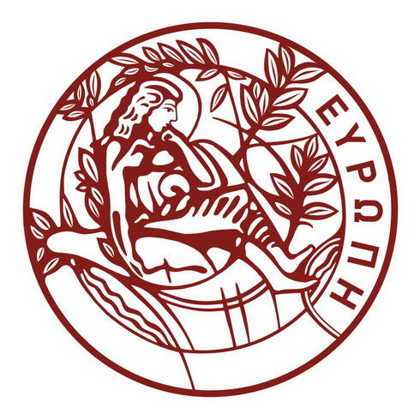

UNIVERSITY OF CRETE

KEDIVIM Centre of Training and Lifelong Learning

Email: kedivim@uoc.gr
Τel. 2810 393661
Heraklion 27/8/2024

PRESS RELEASE

Within the framework of the Center for Training and Lifelong Learning of the University of Crete, an 8-month online seminar is offered to Science and Engineering graduates, who seek to enhance their skills in contemporary technologies (Python Programming, Data Processing, Machine Learning). The official language of the seminar is English. The programme will be implemented by synchronous & asynchronous distance learning.
Python & Machine Learning
Start date : 1st October 2024

Registration deadline: September 23, 2024.

Applications are submitted on the online platform of the University of Crete :

https://kedivim.uoc.gr/index.php/en/application-forms/course-application-form

Tuition Fees: 500 euros

For more information:

Website: https://kedivim.uoc.gr/index.php/en/programmata-2/sustainable-development/334-python-and-machine-learning-4

email: edit-kedivim@math.uoc.gr

Toutors:

Dimitris Kalopsikakis, Lab Teaching Staff at University of Crete MSc/BSc Computer Science / Mathematics

Nikos Christakis, Researcher at University of Crete PhD in Physics

